TEMPERATURE AND HUMIDITY CHECK

# WOKWI LINK:

<https://wokwi.com/projects/364590164676177921>

# PROGRAM :

import random import time from machine

import Pin, PWM, ADC TEMP_THRESHOLD

= 30

HUMIDITY_THRESHOLD = 70

BUZZER_PIN = 5

BUZZER_FREQ = 2000 BUZZER_DUTY = 512 buzzer =

PWM(Pin(BUZZER_PIN), freq=BUZZER_FREQ, duty=0)

HUMIDITY_PIN = 34 TEMPERATURE_PIN

= 35 adc = ADC(Pin(HUMIDITY_PIN))

adc.atten(ADC.ATTN_11DB)

while True: temperature =

random.uniform(10, 45) humidity = adc.read()

/ 4095 * 100 print("Temperature:

{:.2f} C, Humidity: {:.2f}

%".format(temperature, humidity))

if temperature > TEMP_THRESHOLD or humidity >

HUMIDITY_THRESHOLD: print("ALARM! Temperature or

Humidity is too high!")

buzzer.duty(BUZZER_DUTY)

time.sleep(0.5) buzzer.duty(0)

time.sleep(0.5)

time.sleep(1)

# Connection diagram :

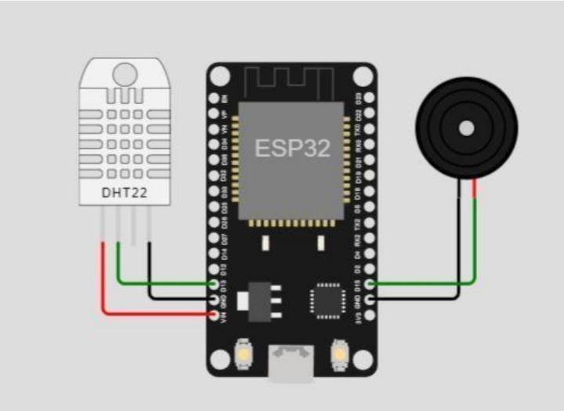

# Output:

